Q: How to check a variable’s type?

A: First, assign a value to the variable. For example:

>>> n = 71

Then, use **type** function with the format **type**(variable) to check what type it belongs to. For example:

>>> n = 71

>>> type(n)

<class ’int’>

Q: In what cases, you will get SyntaxError from the compiler telling you that some of your variables have invalid names? Can you give 3 different examples of invalid names?

A: When we give invalid names to variables, such as:

* Names that do not begin with a letter or an underscore (_)
* Names that contain illegal characters (everything other than letters and underscore)
* Names that are Python keywords – words that define Python’s syntax rules and structures. The full list of keywords is:

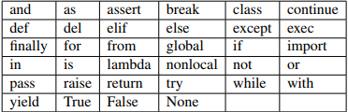

Examples of invalid names are: 1235anhcodanhroinhipnaokhong, del, khongco$